CAS PY 106

Prelecture Note 14

1. Junction Rule
2. 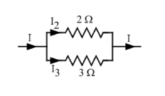
3. Junction is place where three or more current paths meet
4. Junction rule: the total current coming into junction equals the total current going out from a junction
5. In the picture, 2 Ohms resistor is in parallel with a 3 Ohm resistor
6. Current I come into junction before the resistors, splitting into two currents I2 through the 2 Ohms resistor and I3 through the 3 Ohms resistor
7. Junction rule tells us that I = I2 + I3
8. How much current?
9. Fraction of current I passing through resistor 2 Ohms resistor:

Assume V = 6

R = 1 / (1/3+1/2) = 6/5

I = 5

V = 6 for both paths

I2 = 6/2 = 3

I3 = 6/3 = 2

I2 takes 3/5 and I3 takes 2/5 of the current

1. Conservation of ?
2. The junction rule is actually conservation law in disguise. It represents conservation of charge
3. The loop rule
4. Second rule we can apply to circuit is the loop rule: sum of all potential differences around a closed loop equals zero
5. When a charge goes around a complete loop, returning to its starting point, its potential energy must be same.
6. Positive charges gain energy when they go through batteries from the – terminal to the + terminal, and give up that energy to resistors as they pass through them
7. The loop rule
8. 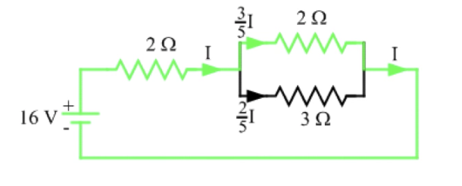
9. Apply loop rule to following circuit to determine current from the battery
10. Going from the – terminal to the + terminal across a battery is positive V, magnitude equal to voltage
11. Going through resistor in same direction as current is negative V, with magnitude of I \* R
12. Going the other way flips the signs

16V – I \* 2 Ohms – 3/5 \* I \* 2 Ohms = 0

16 – 16/5 \* I = 0

I = 5 amps

1. Another method:

16V – I \* 2 Ohms – 2/5 \* I \* 3 Ohms = 0

16 – 16/5 \* I = 0

I = 5 amps

1. Conservation of ?
2. The loop rule is actually conservation law in disguise. It represents conservation of energy